**BLADE TABLE FANS:**

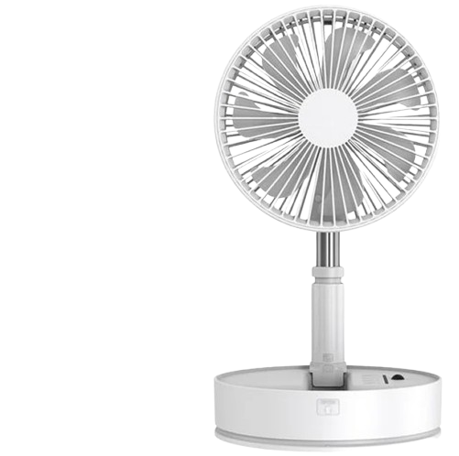

**Price: 8,400.00**

The Blade Table Industrial Fan is a heavy-duty ventilation solution, designed for maximum airflow and efficiency in demanding industrial environments. With its unique blade table design, this fan provides a high-volume, low-speed airflow that is ideal for cooling large areas, improving air quality, and increasing productivity. Its rugged construction, adjustable speed settings, and durable components ensure reliable operation, making it an ideal choice for factories, warehouses, and manufacturing facilities that require powerful and efficient ventilation solutions.

**Key features of blade table include:**

* **Compact Design** – Space-saving and easy to place on tables or desks.
* **Adjustable Angles** – Allows for customizable airflow direction.
* **Quiet Operation** – Designed to run quietly for minimal disruption.
* **Multiple Speed Settings** – Offers varying airflow speeds for comfort.
* **Energy Efficient** – Consumes less power for cost-effective cooling.
* **Portable** – Lightweight and easy to move around.
* **Durable Blades** – Sturdy, long-lasting blades for consistent performance.